BISHOP LUFFA COURSE MAP

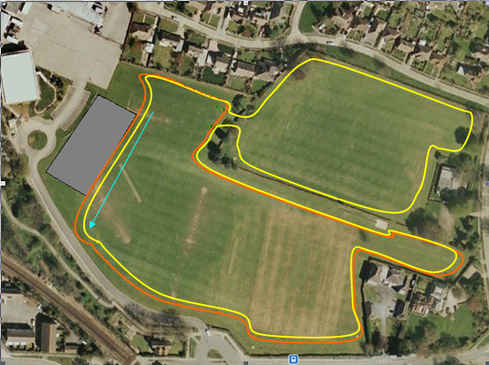

LOOPS:
Blue Start 50m Approx
Small Orange 900m Approx
Large Yellow 1450m Approx
Red Finish 50m Approx

Arrival from 1.15pm onwards

Team managers briefing 2.15

RACE Race Distances Years Time
Year 5 & 6 Girls: (1 large) 1500m (Year 5/6) 2.25
Year 5 & 6 Boys: (1 large) 1500m (Year 5/6) 2.35
Year 7 Girls (2 Small) 1950m (Year 7) 2.45
Year 7 Boys (1 small & 1 large) 2500m (Year 7) 3.00
Year 8 Girls (1 small & 1 large) 2500m (Year 8) 3.15
Year 8 Boys: (2 small & 1 large) 3350m (Year 8) 3.30

Presentation 3.45
Departure 4.00

