
Chichester Area Bronze Ambassador Conference 2020

Date: Thursday 27th February 2019
Venue: Chichester area TBC
Time: 12:30-16:00
Numbers: Up to 4 year 5 students from any Primary School & 4 existing Yr6 ambassadors
New Ambassador Specification:
-Year 5
-Be a positive role model within the school

Essential attributes- potential or demonstrated:
- Ability to influence and inspire other young people.
- Ability to lead and manage other young leaders.
- Excellent communication skills with other young people and adults.
- Ability to show initiative and take responsibility.
- Ability to portray a positive image and be a good role model to young people.
- Organised, with good time management skills.
- Passionate about PE & School sport (not necessarily elite performer)

Roles and Responsibilities:
-To increase participation and healthy lifestyles in their school.
- To promote the positive values of sport in and through sport.
- To be an ambassador and role model advocating PE and school sport.
-To be the young people’s voice on PE and school sport in their school

Conference outcomes:
-Students to understand the importance of a Bronze YA
-Their role and responsibilities
-Why they have been selected
-Introduction of project management
--Introduction of a school enhancing sport projects
-“Sprit of the Games” School Games Values

To book your school’s allocated slot - please book on via the SSP website.
- Deadline for bookings – Friday 7th February 2019
- There must be a staff member present on the day- someone involved with PE school sport
- A spreadsheet sent out after booking for extra info- e.g. child names, top size etc

Kind regards.

Sean O’Connor
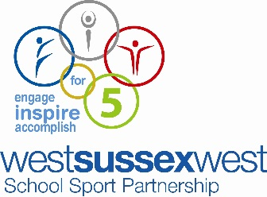
School Sport Partnership Manager (SGO)

