
Bronze Ambassador Conference 2020-21

Date: Monday 9th November
Venue: Virtual
Numbers: Resources and activities will be aimed at 10 pupils. This can be adapted or run multiple times in school.
New Ambassador Specification:
-Year 5
-Be a positive role model within the school

Essential attributes- potential or demonstrated:
- Ability to influence and inspire other young people.
- Ability to lead and manage other young leaders.
- Excellent communication skills with other young people and adults.
- Ability to show initiative and take responsibility.
- Ability to portray a positive image and be a good role model to young people.
- Organised, with good time management skills.
- Passionate about PE & School sport (not necessarily elite performer)

Roles and Responsibilities:
-To increase participation and healthy lifestyles in their school.
- To promote the positive values of sport in and through sport.
- To be an ambassador and role model advocating PE and school sport.
-To be the young people’s voice on PE and school sport in their school

Conference outcomes:
-Students to understand the importance of a Bronze YA
-Their role and responsibilities
-Why they have been selected
-Introduction of project management
--Introduction of a school enhancing sport projects
-“Sprit of the Games” School Games Values

Only schools that book on the website will receive the information/resources. Please be aware with multiple schools now delivering this programme to up to a class, bronze ambassador tops this year will not be provided. We feel allocating the traditional 4 would be unfair on other pupils. The additional costs of postage where it is hosted at schools as well as the sheer increase of tops required. This is not possible.
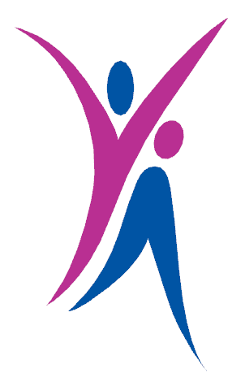
Kind regards.

Sean O’Connor
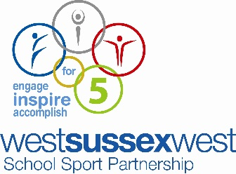
School Sport Partnership Manager (SGO)

