‘X-Fit’ Format

Level 1

Students can be introduced to the event as part of a fitness scheme of work where they practise during PE lessons, with the event itself done either during lesson time where the whole school takes part over the course of a week, or as a special event for those who have been identified as G and T.
Y5/6 Sports Leaders keep score and monitor correct technique.
Results for each event are recorded and in addition, students’ results for each challenge are added together with the total divided by 8 to give an average score. From this, class, Year, key stage and whole school champions can be determined for each challenge.

Level 2

These results are sent to the SSCO/SGO to form area leader boards for -
1. each individual challenge in all Year groups, girls and boys
2. best overall performance based on highest average score in all Year groups, girls and boys
3. highest average score for girls and boys in each age group in each school used to determine best individuals and best overall school

Level 3

Each SGO partnership’s best scores for the categories outlined above are forwarded to produce a county leader board.

Level 4

Leader board comparisons between Sussex, Kent and Surrey can be used to determine regional champions.

Changing circumstances

Should the need for social-distancing and other health measures be abandoned then live competition can be introduced where schools send their best students in each challenge from each Year group to compete at a central venue.

Parameters

A common denominator would be used to highlight any suspicious results. Where schools are challenged on a result they would be asked to provide video evidence of the individual performing the event, avoiding face/ identifying shots where safeguarding issues are present.

Challenge 1 | Crab Crawls
Challenge Description | Taking a reverse crab position with hands and feet flat on the floor, move around the mat without touching it using hands and feet as many times as you can in 30 seconds
Scoring | 1 point for each full circuit  Pupils have one ‘life’ where if they ‘collapse’ and their bottom touches the floor they may carry on but if it happens a second time then the clock must be stopped and their score taken at the point of stopping
Suggested Adaptations for Space/Equipment | Must be performed around a gym mat/ area 1.82m x 1.22m x 25mm (6ft x 4ft x 1")
Adaptation for Inclusivity
Coaching Points for Improvement

Challenge 2 | Bunny Hops
Challenge Description | Pupils use their hands to grip either side of a bench with their feet on one side of the bench. They bounce their feet, both feet together, from one side of the bench to the other.  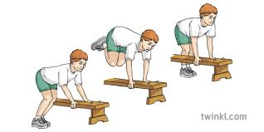
Scoring | One point for each bounce and the feet touch the floor  Right to left = 1  Left to right = 1
Suggested Adaptations for Space/Equipment | If benches are not available/ deemed unsuitable, draw a line with chalk longways down a gym mat (scores will reflect the difference with a 75% deduction made of the total)
Adaptation for Inclusivity
Coaching Points for Improvement

Challenge 3 | Frog Balance
Challenge Description | Pupils squat down with their heels and feet flat on the floor, elbows tucked into knees and palms together. How long can they hold the position?  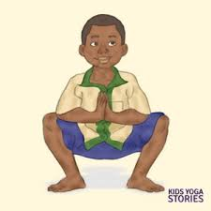
Scoring | One point for every 5 complete seconds
Suggested Adaptations for Space/Equipment
Adaptation for Inclusivity
Coaching Points for Improvement | Keep your head up and look straight ahead

Challenge 4 | Frog Jumps
Challenge Description | Pupils squat down with their hands flat on the floor then jump into the air and land back in a squat with their hands on the floor. How many in 30 seconds?  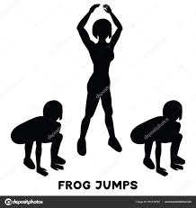
Scoring | One point for every complete jump (squat, jump, back to squat). Hands must be flat on the floor before taking off on every jump.
Suggested Adaptations for Space/Equipment
Adaptation for Inclusivity
Coaching Points for Improvement | Don’t look down!

Challenge 5 | Bear Crawls
Challenge Description | With hands and feet flat on the floor, move around the mat without touching it as many times as you can in 30 seconds  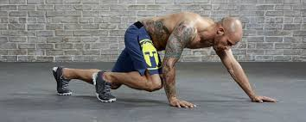
Scoring | 1 point for each full circuit  The pupil has one ‘life’ where if they slip and their tummy, elbows or knees touch the floor they may carry on but if it happens a second time then the clock must be stopped and their score taken at the point of stopping
Suggested Adaptations for Space/Equipment | Must be performed around a gym mat/ area 1.82m x 1.22m x 25mm (6ft x 4ft x 1")
Adaptation for Inclusivity
Coaching Points for Improvement | Look where you’re going!

Challenge 6 | Starfish Jumps
Challenge Description | Pupils stand upright, arms by their sides and feet together then jump up with arms and legs outstretched, landing with feet together and arms by their side. How many in 30 seconds?  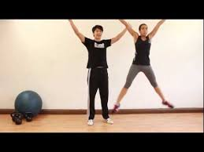
Scoring | One point for every complete jump
Suggested Adaptations for Space/Equipment
Adaptation for Inclusivity
Coaching Points for Improvement | Soften the landing by slightly bending the knees

