BISHOP LUFFA INTER HOUSE CROSS COUNTRY COURSE MAP
WEDNESDAY 9TH FEBRUARY

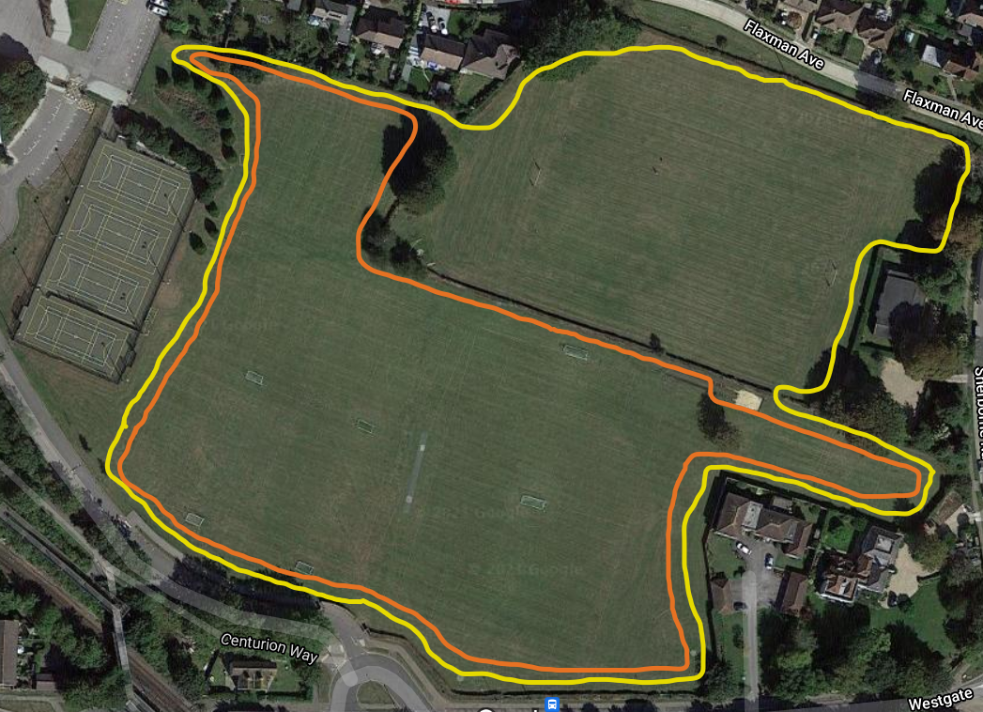

LOOPS:
Blue Start 50m Approx
Small Orange 900m Approx
Large Yellow 1200m Approx
Red Finish 30m Approx

RACE Race Distances
14:00pm - Year 5-6 boys and girls 2400m Start – Yellow Loop x2 - Finish
Presentation in the Sports Hall at 14:25pm
14:15pm Junior boys and girls Y7-8 3000m Start – Yellow Loop – Orange Loop x2 - Finish
14:35pm Intermediate boys and girls Y9-10 3300m Start - Orange Loop - Yellow Loop x2 – Finish

14:50pm Senior boys and girls Y11-13 4500m Start – Orange loop – Yellow Loop x3 – Finish Presentation is the Sports Hall at 15:20pm

Team sheet
Please complete the below team sheet by Friday 7th January and return to Tim Godfray, GodfrayT@bishopluffa.org.uk. Race numbers will be supplied on the day, please bring your own safety pins, runners will need four pins, one for each corner of their race number.

School name:
Team manager/lead teacher:
Contact number on the day:
Email contact:
West Sussex Area Cross Country Team Sheet 2022

Race number (leave blank) | Full name | Age group  (Y5/6, junior boys/junior girls/ inter boys/inter girls/snr boys/snr girls)
Add extra rows if required

